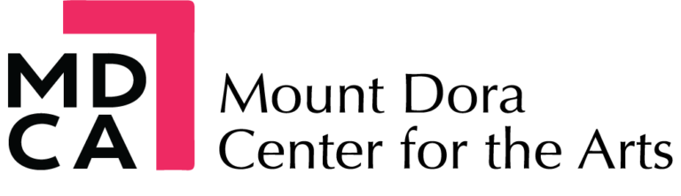
2026/27 Art Camp Scholarship Application
Our goal is to make art accessible to every child. Limited scholarships are available based on financial need and funding.
Child: _______________________________________ Age today: _____Birthday__________
Parent/Guardian: _________________________________________________________
Phone: _____________________________ Email: ________________________________
Address: ________________________________________________________________
City: __________________________ ZIP: __________
Camp Week(s) Requested :
Summer 2026 ☐wk1 June 1-5 ☐wk2 June 8-12 ☐wk3 June 15-19 ☐wk4 June 22-26 ☐wk5 June 29-July 3 ☐wk6 July 6-10 ☐wk7 July 13-17 ☐wk8 July 20-24 ☐wk9 July 27-31
Winter 2026 ☐Session 1 Dec 21-22 ☐ Session 2 Dec 21-22
Spring 2027 ☐ Mar 22-26
Scholarship Requested: ☐ Half Day AM ☐ Half Day PM ☐ Full Day
Why would your child benefit from a scholarship? Include any financial circumstances:
_______________________________________________________________________________________
_______________________________________________________________________________________
_______________________________________________________________________________________
_______________________________________________________________________________________
Previous MDCA Art Camp? ☐ Yes ☐ No
Free/Reduced School Meals? ☐ Yes ☐ No ☐ Prefer not to answer
Agreement: I certify the information above is true. I understand scholarships are limited, based on need and available funding. I understand that application is not a guarantee of acceptance.
Parent/Guardian Signature: __________________________________________ Date: ____________
FOR OFFICE USE ONLY
Received on: __________ Award: ☐ Full ☐ Partial ☐ Not Awarded
Notified on_____________ by: __________________________
Notes: ________________________________________________________

